Ideation Phase
Brainstorm & Idea Prioritization Template

Date | [DD Month YYYY]
Team ID | [Team ID]
Project Name | Automated Network Request Management in ServiceNow
Maximum Marks | 4 Marks

Brainstorm & Idea Prioritization Template:
Brainstorming provides a free and open environment that encourages everyone within a team to participate in the creative thinking process that leads to problem solving. Prioritizing volume over value, out-of-the-box ideas are welcome and built upon, and all participants are encouraged to collaborate, helping each other develop a rich amount of creative solutions.
Use this template in your own brainstorming sessions so your team can unleash their imagination and start shaping concepts even if you're not sitting in the same room.
Reference: https://www.mural.co/templates/brainstorm-and-idea-prioritization
Step-1: Team Gathering, Collaboration and Select the Problem Statement
Team gathering. The project team met to agree the problem to solve, the platform (ServiceNow) and the time available. Team members who took part:
Team member | Role in brainstorming
[Team Leader / Team Members — names and roles] | [Facilitator / Idea contributor]
[Name] | [Role]
[Name] | [Role]
Problem statement selected (How might we…?)
How might we let users request a new or existing network connection through one structured ServiceNow form, and automatically record, acknowledge, approve and fulfil that request instead of handling it manually through phone calls and emails?
Ground rules applied: stay on topic, encourage wild ideas, defer judgement, build on the ideas of others, go for volume, and keep ideas visual.

Step-2: Brainstorm, Idea Listing and Grouping
Every idea was written on a separate note and then grouped into five themes. Ideas are numbered I1–I18 so they can be traced into the prioritisation grid in Step-3.
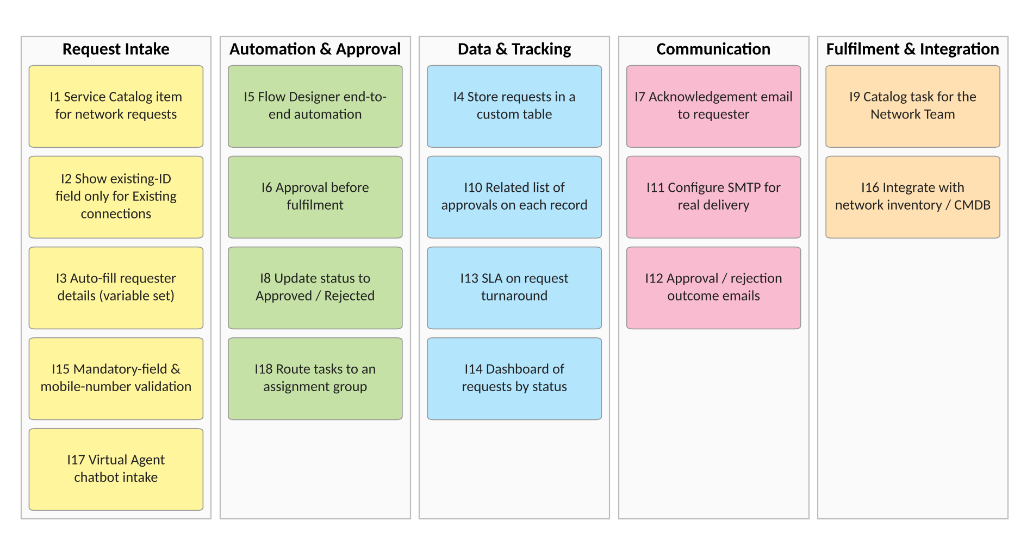
Figure 1: Brainstormed ideas grouped by theme

Step-3: Idea Prioritization
Each idea was placed on an Importance × Feasibility grid. Green ideas were implemented in this project; orange ideas were judged valuable but were not implemented and are recorded as future scope.
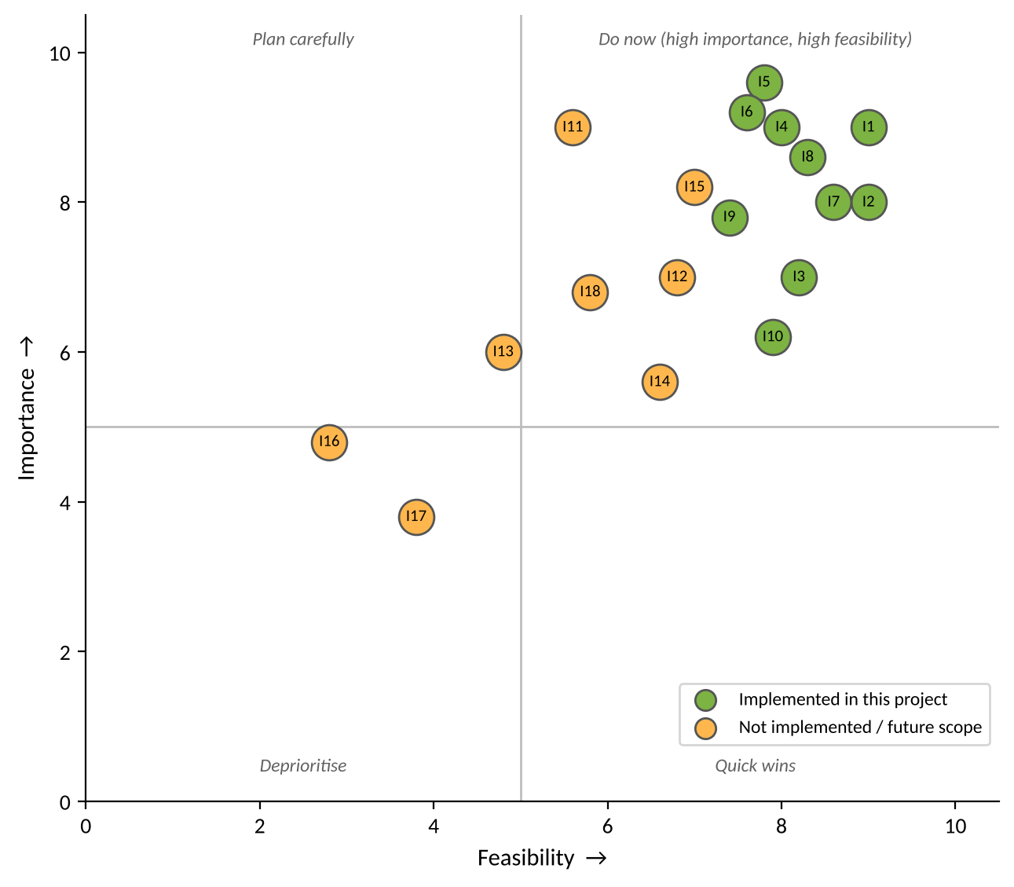
Figure 2: Idea prioritisation (Importance vs Feasibility)
Priority | Ideas | Outcome
1 — Implement now | I1, I2, I3, I4, I5, I6, I7, I8, I9, I10 | Implemented: catalog item, UI Policy, variable set, custom table, flow, approval, email record, status update, catalog task, approval relationship.
2 — Next increment | I11, I12, I15, I18 | Not implemented. SMTP delivery, outcome emails, validation and assignment-group routing.
3 — Later | I13, I14 | Not implemented. SLA and reporting dashboard.
4 — Deprioritised | I16, I17 | Not implemented. Inventory/CMDB integration and chatbot intake.

